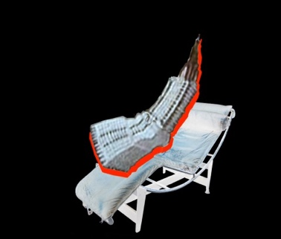
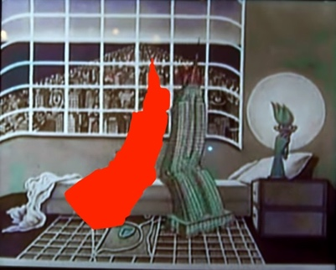
4.s15
Architectural Identifications

Instructor: J. Yolande Daniels
Units: 3-0-9
Credit: G
Schedule: Tu 11:30am-2:30pm
Location: N52-399

COURSE DESCRIPTION

A workshop that explores the identity and production of Western/Modern Architecture from a cultural and critical theory perspective through four lenses (Objects, Modes, Positioning, and Agency). Each lens assists a view of how the field of architecture mediates and constructs spatial forms and spatial knowledge. Objects and Modes, assists the identification exploration of a range of material tropes from techno-determinism (machine aesthetics, structural rationalism) to vaporization (transparency, whiteness), and operative binaries (object v. space, model v. analogue, abstraction v. ornamentation, etc.). Positioning and Agency, assist the exploration of polemics within the discipline including autonomy, agency, socio-spatial hierarchies, etc.

The workshop draws connections between thought and forms in a non-linear manner along two adjacent and conversant paths. Each theme introduced is considered through the lens of the standard cannon of Western/Modern Architecture: Architecture + “X”. The primacy of Western/Modern thought and forms has been predicated on an (often) absent “other.” In a turn toward a heterogeneous understanding of the discipline, the themes are also considered through the lens of power relations and subordinacy i.e., what the cannon leaves out: Architecture + “X” + subordination. The spaces we inhabit are social constructions that begin in the mind before they are materialized as objects and spaces. How can the capacity for architecture as a discipline to address heterogeneous visions and desires be expanded? And how can critical thinking about inherited tools and ideas further new manners of production?

By paralleling an analysis of the tools of the architect with a process of creating, this hybrid seminar + workshop provides a critical framework for production. It is structured by group discussions of assigned readings and precedents that inform a series of assignments. Readings encourage consideration of the social relations and confluence of ideas that produce architectural forms. Assignments encourage consideration of material processes and the crafting of objects from an individual perspective.

Each assignment defines a threshold. A threshold can be a material element that demarcates the approach or crossing of a boundary-- a point of entry, a line, a tread, and threshold can be immaterial—it is on the verge of, the opening to, the locus of, a point of departure. The first set of threshold assignments are architectural details that establish material assemblies and aesthetic sensibilities through a catalog of facades, vestibules, and portals. The second set of thresholds are less easily identified architecturally as they explore immaterial shifts, transitions, limits, and boundaries.

