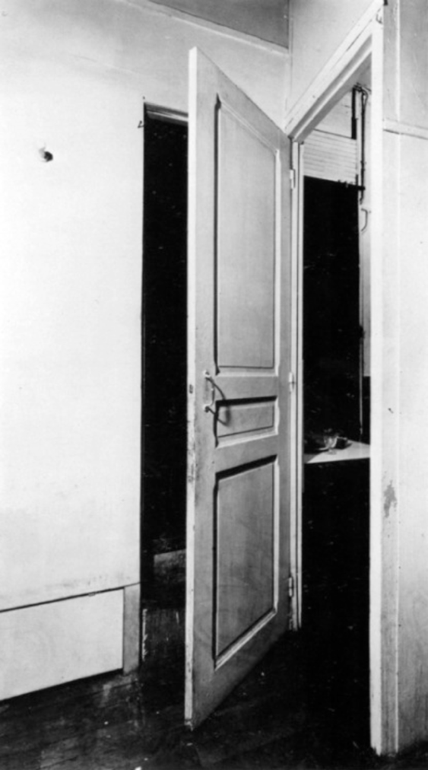

COURSE DESCRIPTION
Architecture & Thresholds offers the opportunity to explore the architectural design potential of entries and exits—of liminal and in between spaces. As illustrated in Marcel Duchamp’s door 11 rue Larrey from 1927, every threshold is on the verge of--it is both an opening to and closure of. Each threshold holds the space between two conditions.

The approach of the class is informed by a range of iterative and rule-based practices in literature, mathematics, art, music and architecture. In art and music, instructional compositions informed by repetition, variation, and singularity (uniqueness) from the chance compositions of John Cage to the wall drawings of Sol Le Witt to the painting and constructions of the architecture studio Pezo von Ellrichshausen. Other models the exploration in Exercises in Style by Raymond Queneau and 99 Variations on a Proof by Philip Ording, two works that begin with a simple premise that is reinvented one hundredfold by a new set of principles, techniques, contexts, and histories.

Following the model of the OuLiPo group, whose members applied constraints and mathematical rules to conceive of and structure narratives, students will apply the logic and rules of architectural precedents of their choice to produce a series of variations. Students first select a building threshold from a project that they have previously designed as the foundation for the new threshold variations. The threshold variations will be a detailed study and analysis of select architectural precedents. For the final project, students analyze their threshold variations in a final threshold redesign and physical model at full or half scale. Architecture & Thresholds explores the refinement of architectural design concepts through iterative studies, architectural detailing and construction mock-ups.

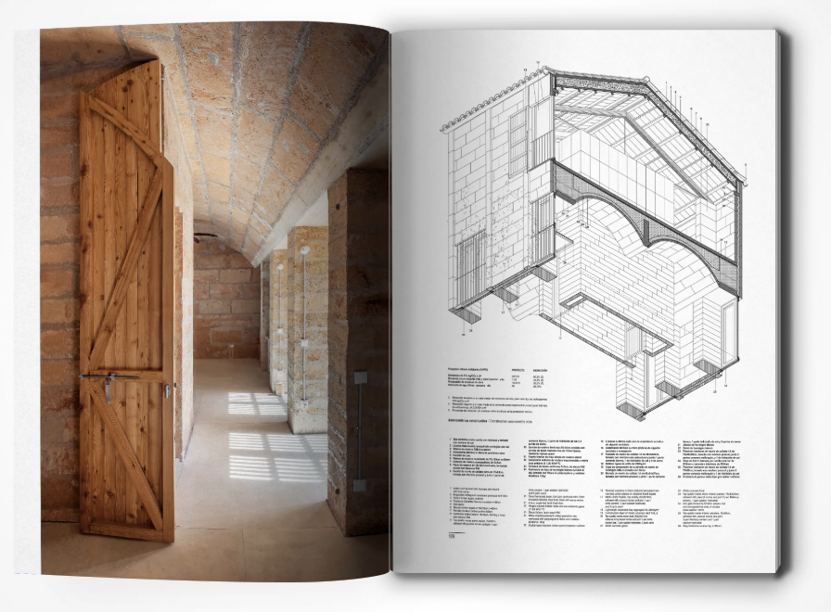

Students are encouraged to choose architectural precedents that continue or challenge the logic of their work. The architectural precedents will be drawn from editions of GA Detail, Global Architecture, El Croquis, and when possible, detailed vernacular and traditional examples (African, Islamic, Japanese, and European). Since the threshold is from a design that each student gave much consideration previously, the final speculation on the threshold design hints toward alternative design approaches and potentials in building design that students can carry forward.

COURSE SCHEDULE/ OUTLINE
SCHEDULE | OVERVIEW/RESOURCES/REQUIREMENTS
Wk. 01: T. Feb 04 | Topic: Information Session
Wk. 02: M. Feb 10 | Topic: Overview
Wk. 03: Tu. Feb 18 (Holiday M Feb 17) | Tectonic 1: Selection and Discussion
Wk. 04: M. Feb 24 | Tectonic 1a: Presentations
Wk. 05: M. Mar 03  (Add final Mar 07) | Tectonic 2: Selection and Discussion
Wk. 06: M. Mar 10 | Tectonic 2a: Presentations
Wk. 07: M. Mar 17 | Tectonic 3: Selection and Discussion
Wk. 08: M. Mar 24 | Spring Break
Wk. 09: M. Mar 31 | Tectonic 3a: Presentations (REMOTE)
Wk. 10: M. Apr 07 | Tectonic 4: Selection and Discussion (REMOTE)
Wk. 11: M. Apr 14 | Tectonic 4a: Presentations
Wk. 12: M. Apr 21  (Drop final Apr 22) | Holiday
Wk. 13: M. Apr 28 | Tectonic 5: Selection and Discussion
Wk. 14: M. May 05 | Tectonic 5: Final Presentations
Wk. 15: M. May 12  (Last class) | Wrap up.

CLASS FORMAT/ASSIGNMENTS
- Students select a building threshold from a project that they previously designed.
- This threshold will be the foundation for a series of new threshold variations.
- The series of threshold variations will be explored and represented in five threshold detail assignments.
- Each of the first four assignments are split between two classes. In the first class a precedent and tectonic is selected, and in the second class, the revised threshold detail assignment is presented.
- The deliverable for each of the first four assignments is a plan oblique and a section oblique that details that details the threshold and represents the interior and exterior facades.
- The fifth and final assignment also includes a physical model as the final project.

LEARNING OBJECTIVES
- Study and interpret the design and details of 4 architectural precedents
- Apply an understanding of each of four architectural precedents to another building threshold.
- Analyze the structure, composition, logic and materiality of four architectural precedents.
- Study, document, and interpret the logic and rules of the precedent.
- Evaluate your original design through the analyses of the concepts and principles of the four architectural precedents.
- Interpret your analyses to design a fifth new threshold.
- Create a new threshold prototype for the original building design that synthesizes and applies knowledge gained from the precedent analyses and rule-based studies.

PARTICIPATION REQUIREMENTS
- Attend weekly sessions.
- Complete recommended readings and post commentary (Sunday before class).
- Contribute to the collective discussion in the classroom.
- Complete all detail assignments in time for class presentations and discussions.
- Produce a final analytical threshold and detailed physical mock-up.

ATTENDANCE POLICY
- Attendance for the full duration of each class is mandatory unless prearranged with the instructor.
- Three excused absences are allowed for the semester. An excused absence is defined as one that was discussed with and approved by the professor at least 24 hours prior to the date of absence, or a family or medical emergency that is confirmed by your physician or a dean in Student Support Services.
- Unexcused absences will reduce the course grade by half a letter grade, at minimum. Late arrival or early departure from class will count as a partial absence.

GRADES
- Readings and posting in the class forum (15%)
- Contribution to class discussions (15%)
- Assignments #1-4 (50%)
- Assignment #5 (20%)

GRADING RUBRIC
- A: Excellent — Project surpasses expectations in terms of inventiveness, appropriateness, verbal and visual ability, conceptual rigor, craft, and personal development. Student pursues concepts and techniques above and beyond what is discussed in class.
- B: Above Average — Project is thorough, well researched, diligently pursued, and successfully completed. Student pursues ideas and suggestions presented in class and puts in effort to resolve required projects. Project is complete on all levels and demonstrates potential for excellence.
- C: Average — Project meets the minimum requirements. Suggestions made in class are not pursued with dedication or rigor. Project is incomplete in one or more areas.
- D: Poor — Project is incomplete. Basic skills including graphic skills, model-making skills, verbal clarity or logic of presentation are not level-appropriate. Student does not demonstrate the required design skill and knowledge base.
- F: Failure — Project is unresolved. Minimum objectives are not met. Performance is not acceptable. This grade will be assigned when you have excessive unexcused absences.

EVALUATION CRITERIA
Grades will be assessed according to the following criteria:
- Attendance
- Active and constructive involvement in discussions and in-class activities.
- Completion of readings and assignments.
- Ability to establish an iterative design process.
- Clarity of analyses and application.
- Capacity to reflect upon and self-critique the work produced.
- Ability to respond to criticism of classmates and the from instructor.
- Precision and rigor in execution and the clarity of presentations.

EVALUATION METHODS
- In addition to the quantitative evaluation of attendance, participation, and assignments, the qualitative development of an iterative analytical process, application of design research, clarity in representation and design integration are fundamental to successful completion of the course.
- In-class discussions are intended to provide the opportunity for self and peer evaluation. Instructional support will be delivered through lectures and discussions, and office hours.

USE OF GENERATIVE AI
- Generative AI tools may be used for the first four assignments.
- Use of generative AI tools must be credited.
- The use of AI tools to generate designs using visual, text, spoken prompts for the fifth and final assignment (the analysis and prototype) is not allowed.

ACADEMIC INTEGRITY/ HONESTY
Massachusetts Institute of Technology students are here because of their demonstrated intellectual ability and because of their potential to make a significant contribution to human thought and knowledge. At MIT, students will be given unusual opportunities to do research and undertake scholarship that will advance knowledge in different fields of study. Students will also face many challenges. It is important for MIT students to become familiar with the Institute’s policies regarding academic integrity: Academic Integrity at MIT: A Handbook for Students

PERSONAL CONDUCT
The instructor and students in this course are expected to act responsibly, ethically, and with respect for the dignity of all others, both within and outside the classroom. Issues relating to personal conduct, including discrimination and harassment, will be taken extremely seriously. Take the time to become familiar with MIT’s major policies on personal conduct: MIT Policies: Conduct and Community Standards
STUDENT SUPPORT - MEDICAL
If you are on a Medical Hold due to attesting to potential Covid symptoms, or have tested positive and must isolate, then please contact your instructors so we can make sure you have access to course materials, and we can discuss how we address the missed work. You can also contact Student Support Services for additional assistance.

STUDENT SUPPORT SERVICES (S3)
If you find that something is getting in the way of your ability to attend class, complete work, or take an exam, you should contact a dean in Student Support Services (S3). The deans will provide you with support and help you work with us to determine next steps. We ask that you go to S3 so we know you have had a chance to talk through your situation with someone and to connect with any resources you might need. The walk-in queue is open from 10-12 and 2-4 on weekdays. Appointments can be virtual or in-person, depending on your comfort and convenience. For more information or to join the virtual help queue visit studentlife.mit.edu/s3 or e-mail s3-support@mit.edu.
DISABILITY ACCOMMODATION AND ACCESS SERVICES
MIT is committed to the principle of equal access and an inclusionary environment. Students who need any form of accommodation are encouraged to speak with the instructor as early as possible. Students who need disability accommodations are encouraged to speak with Disability and Access Services (studentlife.mit.edu/das), prior to or early in the semester so that accommodation requests can be evaluated and addressed in a timely fashion.
If you have a disability and are not planning to use accommodations, it is still recommended that you meet with DAS staff to familiarize yourself with their services and resources. Contact Disability and Access Services with any questions at 617-253-1674 or via email das-student@mit.edu.
COURSE COMMUNICATIONS
Updates to the course schedule and content will be issued via Canvas announcements and to your MIT email address. Students are responsible for checking email regularly throughout the course. Students are also encouraged to email the instructor with any questions, concerns, or requests that may arise during the course. Course information, the syllabus, schedule and submission deadlines, and the studio handbooks, will be distributed via Canvas. The Canvas course homepage can be found at: https://canvas.mit.edu/courses/31058

* FINAL COURSEWORK SUBMISSIONS ARE REQUIRED VIA DROPBOX BY THE LAST CLASS TO RECEIVE A GRADE.

BIBLIOGRAPY
- Assigned readings will be posted on Canvas throughout the course.
- Library reserves and digital links of required readings and precedents will be provided when necessary.
BIBLIOGRAPY - PUBLICATIONS (on thresholds, passages, openings, doors)
- Andrews, Stuart and Matthew Wagner, The Dramaturgy of the Door
(Routledge, 2020).
- Bachelard, Gaston, The Poetics of Space (Beacon Press, 1994, (c1964)).
- Boettger, Till, Threshold Spaces: Transitions in Architecture: Analysis and Design Tools (Birkhäuser, 2014).
- Kimmel, Laurence, Architecture of Threshold Spaces: A Critique of the Ideologies of Hyperconnectivity and Segregation in the Socio-Political Context (Routledge, 2021).
- Perec, Georges, Species of Spaces and Other Pieces (Penguin 1999, c1997).
- Taravati, Golzar, Porta: The Language of Doors (ProQuest Dissertations & Theses, 2009).
BIBLIOGRAPY - PUBLICATIONS (on iteration, serial and rule-based practices)
- Mardones Hiche, Patricio, La Poetica Del Quadrato/Quadratic Poetics, Domus, 2011-05 (947), p.34-39
- Mathews, Harry and Alastair Brotchie, Oulipo Compendium (Atlas Press, 2005, (c1998)).
- Ording, Philip, 99 Variations on a Proof, (Princeton Architectural Press, 2011).
- Piekut, Benjamin, Chance and Certainty: John Cage's Politics of Nature, Cultural Critique, 2013-03, Vol.84 (84), p.134-163.
- Queneau, Raymond, Exercises in Style (New Directions, 2012, (c1947)).
- Singer, Sussana, Sol LeWitt Wall Drawings, 1984-1992 (Kunsthalle Bern, 1992).
- Singer, Sussana, Sol LeWitt Wall Drawings, 1968-1984 (Stedelijk Museum, 1984).
- Skurvida, Sandra, John Cage Composing, Computing, and Curating (Routledge, 2025)
BIBLIOGRAPY - PUBLICATIONS (on Details)
- Allen, Edward and Patrick Rand, Architectural Detailing: Function, Constructibility, Aesthetics (Wiley, 2016, c1931).
- Bizley, Graham, Architecture in Detail II (Elsevier, 2010).
- Cremers, Jan, Ed., Building Openings Construction Manual: Windows, Vents Exterior Doors (Edition Detail, 2016).
- Dickinson, Duo, Expressive Details: Materials, Selection, Use (McGraw-Hill, 1997).
- Diderot, Denis, The Architectural Plates from “Encyclopédie” (Dover, 1995).
- Emmitt, Stephen, John Olie and Peter Schmid, Principles of Architectural Detailing (Blackwell Pub, 2004).
- Ford, Edward R., Five Houses, Ten Details (Princeton Architectural Press, 2009).
- Ford, Edward R., The Details of Modern Architecture (MIT Press, 1996, c 1990).
- Ford, Edward R., The Architectural Detail (Princeton Architectural Press, 2011).
- Heschong, Lisa, Visual Delight in Architecture: Daylight, Vision, and View (Routledge, 2021).
- Herzog, Thomas, Roland Krippner and Werner Lang, Fassaden Atlas, (Birkhäuser, 2013)
- Killroy, Christine, Details in Contemporary Architecture (Princeton Architectural Press, 2007).
- Knobloch, Philip G., Architectural Details from the Early Twentieth Century (American Institute of Architects Press, 1991, c1931).
- Gatz Konrad, Modern Architectural Detailing (Reinhold Pub. Corp., 1963- (c1961)).
- Kumpusch, Christoph, Detail Kultur: If Buildings Had DNA: Case Studies of Mutations (AADCU Program, 2016).
- Melet, Ed., The Architectural Detail: Dutch Architects Visualise Their Concepts (Nai Publishers, 2002).
- Radford, William, Old house Measured and Scaled Detail Drawings for Builders and Carpenters (Dover Books, 1983).
- Selected Architectural Details: The Pencil Points/Progressive Architecture Series (Reinhold, 1944)).
- Tutton, Michael and James Campbell, Eds., Doors: History, Repair and Conservation (Routledge, 2020).
BIBLIOGRAPY - PERIODICALS (Detail Precedents)
- Detail Magazin, GmbH, Institut für Internationale Architektur-Dokumentation, München, https://www.detail.de/aktuelle-ausgabe-1-2-2025
- El Croquis, N. 214 Pezo Von Ellrihausen 2005 2022 Madrid, Spain, https://elcroquis.es/collections/edicion-en-papel
- Global Architecture/ GA document, A.D.A. Edita, https://www.ga-ada.co.jp/english/index.html
- Japan Architect/ JA Detail

