AMAZONIA STUDIO, 2025
Manaus, a Fluvial City

MIT Summer + Fall 2025

Instructors: Angelo Bucci, Gabriella Carolini
Semester: Fall, 2025
Manaus, Brazil (July 1st – 10th, 2025) /Fall class meetings in Cambridge (Fridays 9:30am -12:30pm,)
Presentation of Class Proposals at the COP 30 in Belem, Brazil, in November 2025
Course: 4.181 / Credits: 3-0-9 G / Location: Studio 7-434

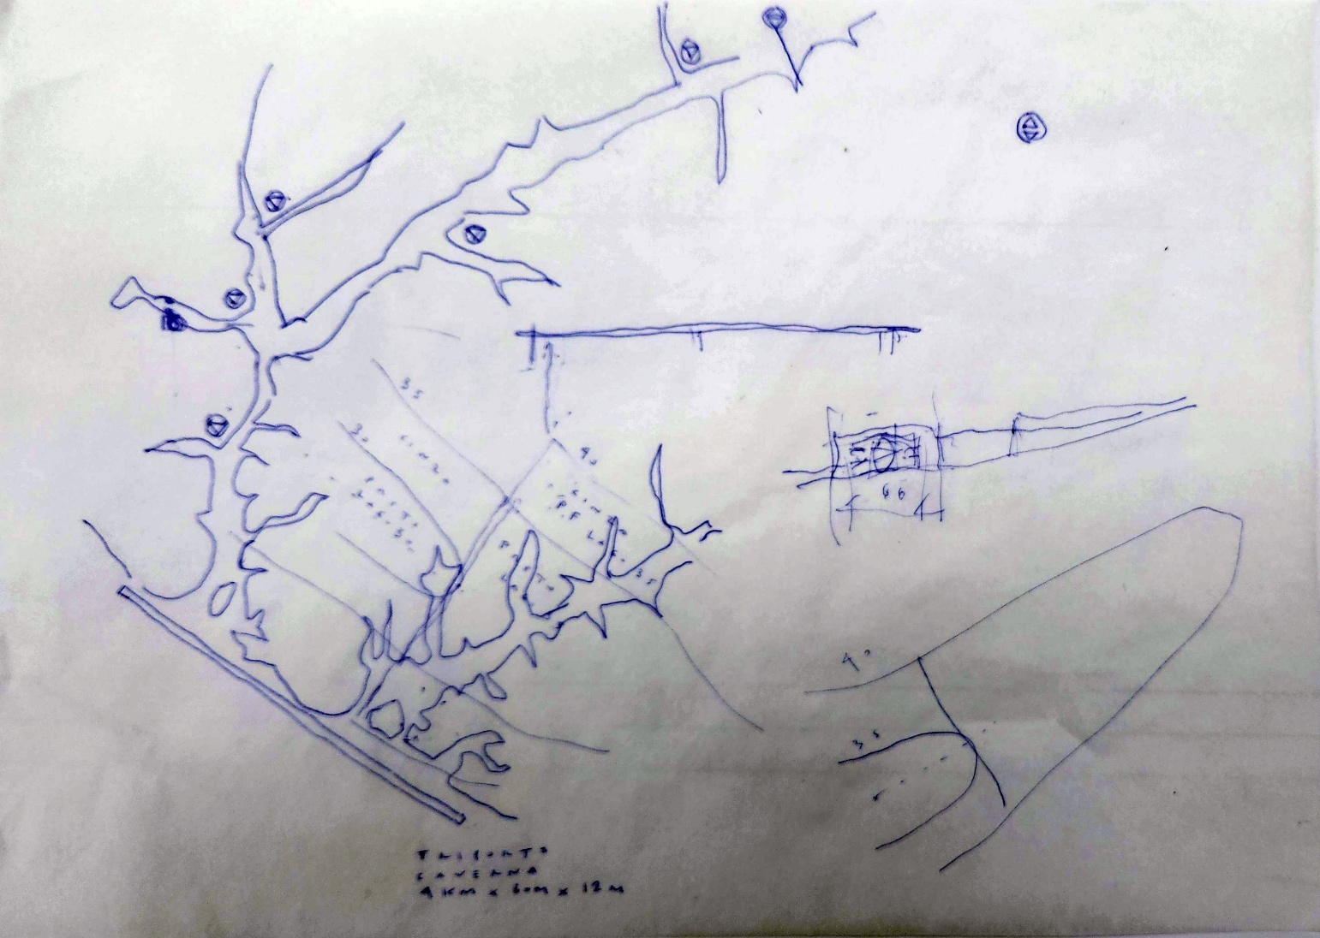
Sketch by Alexandre Delijaicov, FAUUSP, June 2024
Manaus, waterfront on Negro river and igarapes

The Brazilian culture inherited from Brazilian native indigenous peoples the concept of “mutirão” (“Motirõ” in Tupi-Guarani language). It refers to a community coming together to work on a shared task, whether harvesting, building, or supporting one another. By sharing this invaluable ancestral wisdom and social technology, the incoming COP30 presidency invites the international community to join Brazil in a global “mutirão” against climate change, a global effort of cooperation among peoples for the progress of humanity.
by Andre Aranha Correa do Lago, COP30 President Designated. March 10th, 2025

Introduction
Leveraging a five-year relationship between partners at MIT, the Federal University of Manaus (UFAM), and the University of São Paulo (USP), the proposed class is a new collaborative workshop (Architecture) and potential practicum (DUSP) offered during the Summer and Fall 2025 terms by Gabriella Y. Carolini (DUSP) and Angelo Bucci (Architecture). The class objective is to engage Architecture and DUSP graduate students in the design and planning of more resilient housing and sanitation in the largest Amazonian city: Manaus, Brazil. Cities and towns within the Amazon region of South America are growing more rapidly than any other within the continent, hitting population growth rates of 20% over the past decade. Accompanying this growth in Manaus is the accumulation of solid waste and untreated wastewater in riverways, and the enclosure of traditional river canals in the urban core with “upgraded” housing developments. These phenomena risk foreclosing Manaus’s immense potential as the prototype of a resilient Amazonian fluvial city with the capacity to recapture its historical role as a major cultural, social, and economic reference point in the region. This class thus aims to provoke a shift in the design thinking and planning in Manaus by recentering the city’s waterways as a key resource for the vitality of urban life. Earlier decades in Manaus saw the city’s rivers and canals as core community spaces, with recreation, mobility, and cultural functions. This class aims to help reignite the affective memory of those earlier river and landscapes, a memory that remains alive among residents despite of the destruction of the natural landscape and water pollution.
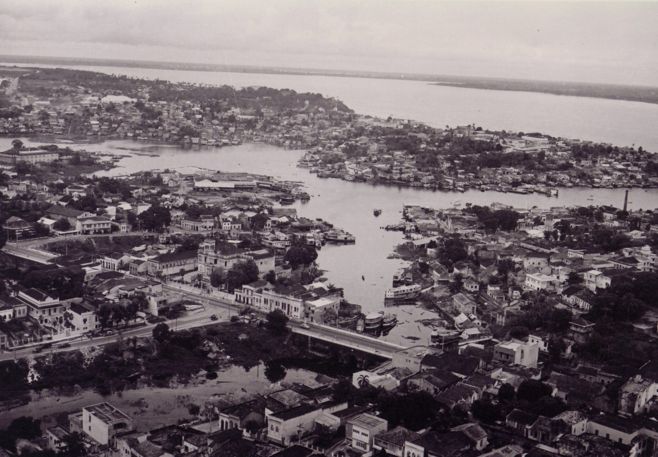
Rio Negro Palace and Igarape Educandos, Durango Duarte Institute
Class Calendar (12 credits):
- Manaus, Brazil (July 01st -10th, 2025): Intense fieldwork (to document current scenes and sites, interview key informants, and gather iconography).
- Fall semester class meetings in Cambridge (Fridays 9:30am -12:30pm): The class objective is to produce plans and designs that provide a resilient alternative to extant housing and sanitation in Manaus.
- Presentation of Class Proposals at the COP 30 in Belem in November 2025

In addition to its weekly meetings at MIT in the Fall 2025 semester, this class involves intense preliminary fieldwork participation in early July in Manaus. During the July field work period, MIT students will partner with architecture and planning students from UFAM and USP to document the local context, learn from local knowledge resources, and to begin ideation and iteration of novel design and planning proposals around the themes of resilient housing and sustainable sanitation systems. A selection of the final class proposals will be featured in an exhibit sponsored by the Inter-American Development Bank in the November 2025 at COP 30 in Belem.

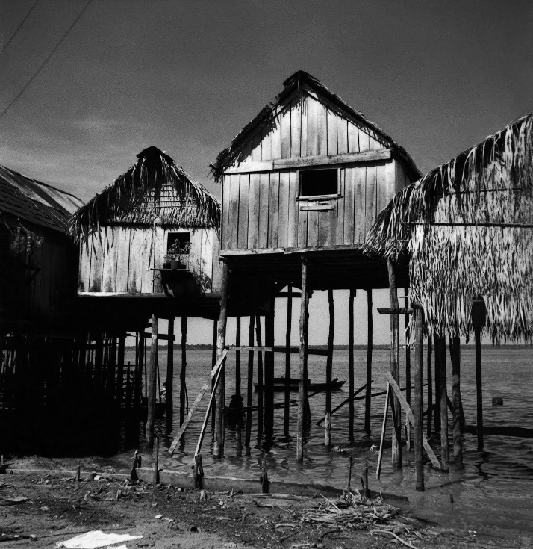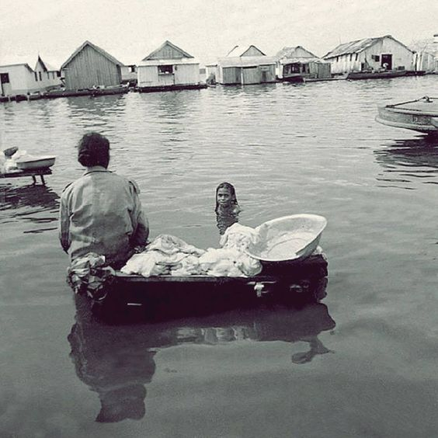
Marcel Gautherot, Stilt houses (palafitas), 1945 Marcel Gautherot, Floating city, 1960’s

Class description:
The global imagination of the Amazon river basin, covering around seven million square kilometers, is dominated by the tropical forest. However, cities and towns within this basin represent some of the fastest growing urban settlements on earth. Over the past decade, nearly one hundred Amazonian cities and towns have seen population growth rates of over 20 percent–far above the under-two percent average across Latin America. Manaus represents one of the cities seeing the most rapid change. With roughly 2.5 million inhabitants, it is today the largest city in the Amazon, located at what is popularly referred to as the “Encontro das Águas” or meeting of the rivers, namely the Negro River (one of the main tributaries and start of the Amazon River) and its confluence with the Solimões River. The city’s fluvial character has long situated it as a central meeting point for ancestral peoples as well as for foreigners who arrived in different migratory cycles. Critically, the Negro River’s annual variation (typically up to 14 meters) has translated into a unique—but also typical for the Amazon—landscape of the built and natural environment. Stilt housing (palafitas), flooded swamp-like forests (igapós), and long river channels (igarapés) traditionally define this landscape and speak to the fluvial culture of Manaus, as well as other urban agglomerations for which the city is a major reference.

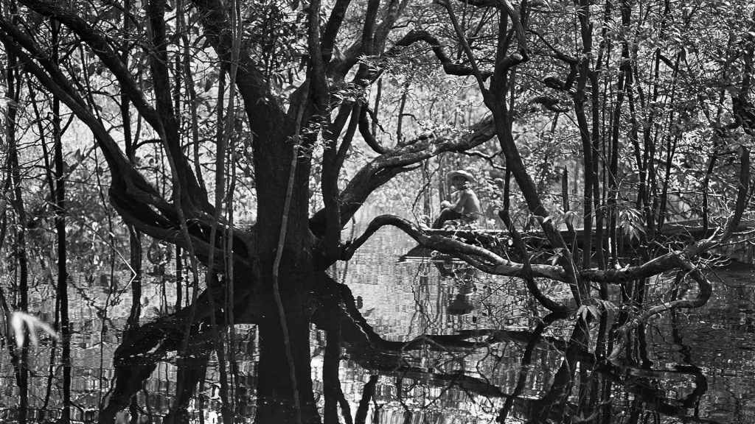
Marcel Gautherot, Igapó, 1958

Today, however, accelerating unplanned and ill-equipped urban growth in Manaus represents a major challenge to its resilience. Continued deforestation and environmental degradation of surrounding towns and villages, coupled by varied water-related risks from draught, flooding, and contamination, have translated into the displacement of Indigenous populations from traditional lands in the Amazon and migration into cities like Manaus. Adequate, resilient housing and infrastructure systems have not been able to keep pace with the demands of this growth. Irregular or informal housing represents more than half the housing stock in Manaus. The city’s waterways, the defining feature of its urban landscape, have become neglected and abused, evidenced in its treatment as the de facto sanitation “solution” for both untreated wastewater dilution and the accumulation of solid waste in igarapés. The waste clogging igarapés in turn represent immense vulnerabilities for the built environment during the rainy season, as Manaus discovered during the unprecedented floods the city experienced in 2021. Further, efforts to “upgrade” housing and resettle communities living in palafitas translated into social housing that physically and culturally repress the city’s canals instead of incorporating them into improvements in the physical and socio-economic life of the city. This class aims to provide an alternative vision of housing and sanitation in this fluvial landscape, recognizing and leveraging the central character of water in Manaus to envision a more resilient Amazonian fluvial city. A selection of the class’s final projects will be featured in a major exhibit hosted by our client, the Inter-American Development Bank’s Cities Lab, at the UN Climate Change Conference (COP 30) in Belém, Brazil in November 2025.

Precedents, strategies and methodology
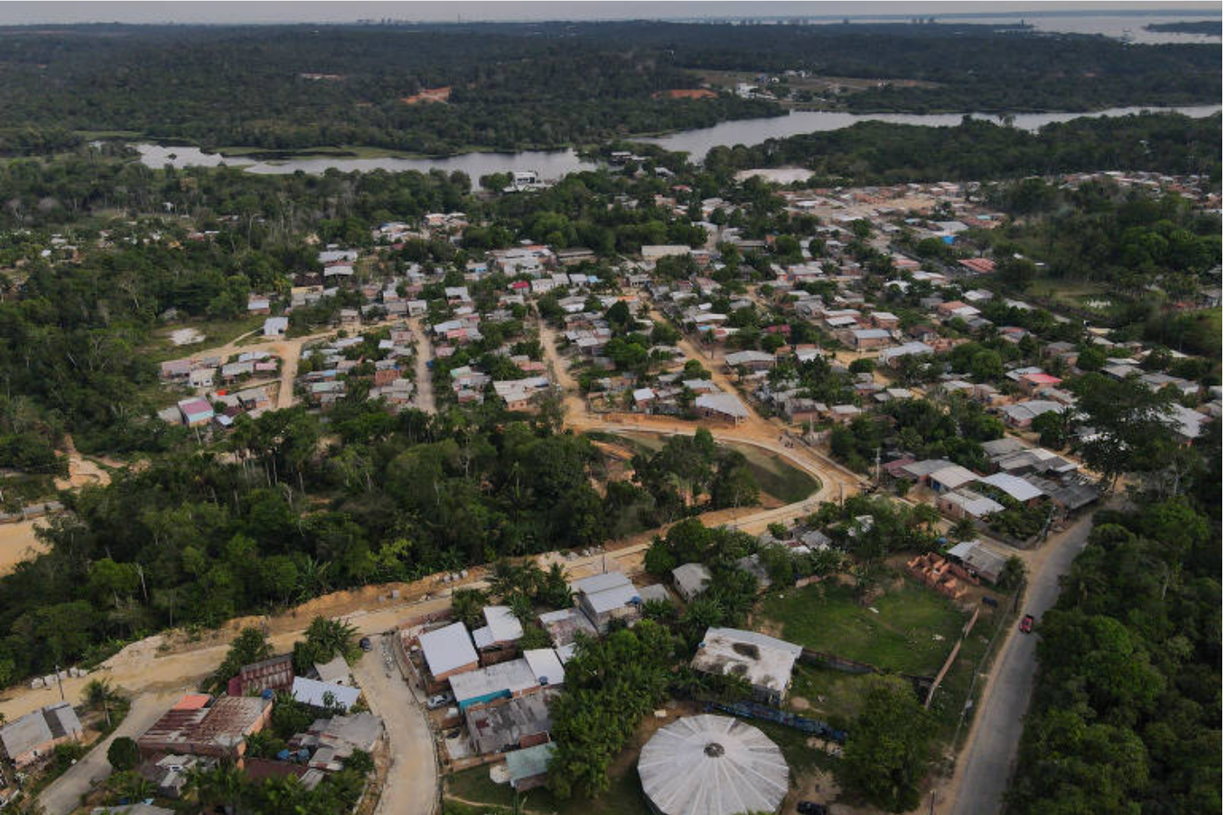
Parque das Tribos, Bruno Kelly, Folha de São Paulo, 2023

The academic collaboration between the schools of architecture and planning at MIT and UFAM, with Professor Marcos Cereto in the latter, started in 2020, while planning the first Studio in Amazonas, that happened yearly since 2021. Cooperation with Professor Alexandre Delijaicov, FAUUSP — whose expertise on the urban rivers topic was built through lifelong research — also contributed to the sequence of MIT Amazonia Studios in Amazonia, going back to 2020, since he has had a role as an expert consultant.
These precedents help define the reality and scope for this current proposal. Our departing point centers on the Parque das Tribos, the first Indigenous neighborhood in the city of Manaus. Parque das Tribos represents one of three critical typologies of vulnerable but important human settlements in the city – namely, that related to formally unplanned urban growth inland from Manaus’s waterways. Another two typologies center on the waterways themselves – literally: palafitas and floating neighborhoods. Palafitas, or stilt housing, is ubiquitous across Amazonia and remain a feature of the urban and peri-urban landscape around Manaus. Floating neighborhoods represent the third type of settlement in the city—with housing and commercial venues essentially unmoored from land in the city. This class will consider both land-based and water-based housing and sanitation concerns in its objectives to reignite the sustainable life of the city in communion with its immensely important waterways, using models, plans, and design to this end.
The trip to Manaus as an intense fieldwork has a clear double goal:
First, it is to document current scenes and sites, in inland sites like the Parque das Tribos and water-based housing along the igarapés waterfront, once places for leisure, where urban beaches and parks remain central, but currently neglected emotional memories of Manaus’s residents. Recording the disastrous turn away from the celebration of water in some of the city’s housing will work as an antithesis, as purpose and (anti) guidelines for the studio work.
Second, the aim is to gather iconography, to be in touch with local knowledge and expertise, and to interview local residents, leaders, and urban experts to help students unlock the meaning and potentiality of the places we will visit.
Historically, housing and water were always paired together in the history of Manaus, evidenced in the local tradition of palafits, or the stilt houses, that cope well with the water-level variations throughout the year. In the last twenty years, a federal policy called PROSAMIM, however, has been dedicated to converting old stilt housing into traditional social housing, intending to keep the people in their original places. However, the shift away from traditional water-based housing typologies and construction resulted in the production of ‘artificial grounds’ in the flood zones of the igarapés. Over the course of time, the supposed correctness of this “modern” housing policy has revealed a crucial mistake in its environmental policy aiming to control water: canalizing and filling the old igarapes.
Designing against this current scenario and more in accordance with local knowledge is an important potential contribution of this class’s work. In short, how can we help to simply recover the front door to waterways in Manaus and transform what was made as a waste dump into the fluvial Amazonian city of the future. The goal of the studio is to produce such hypotheses. The two contrasting scenarios—Manaus today and Manaus as the fluvial Amazonian city of the future—will be presented at the COP30 exhibition; thus each visitor will be able to elaborate their own synthesis.

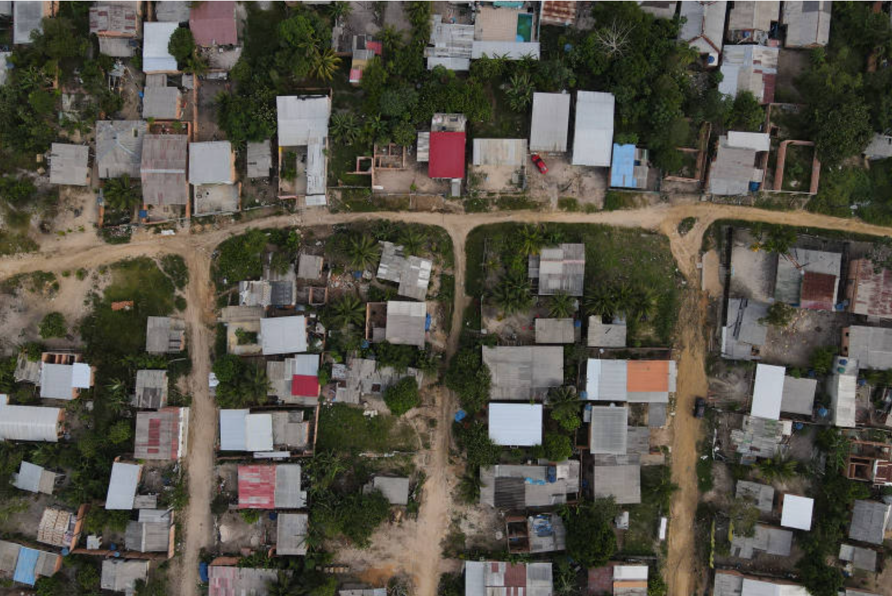
Parque das Tribos, Bruno Kelly, Folha de São Paulo, 2023

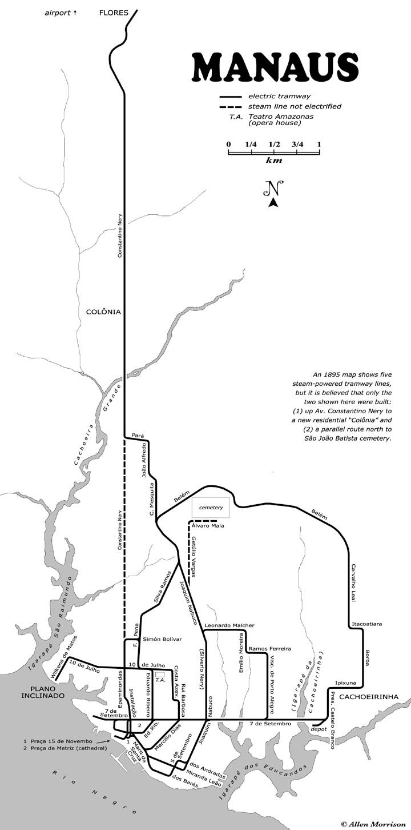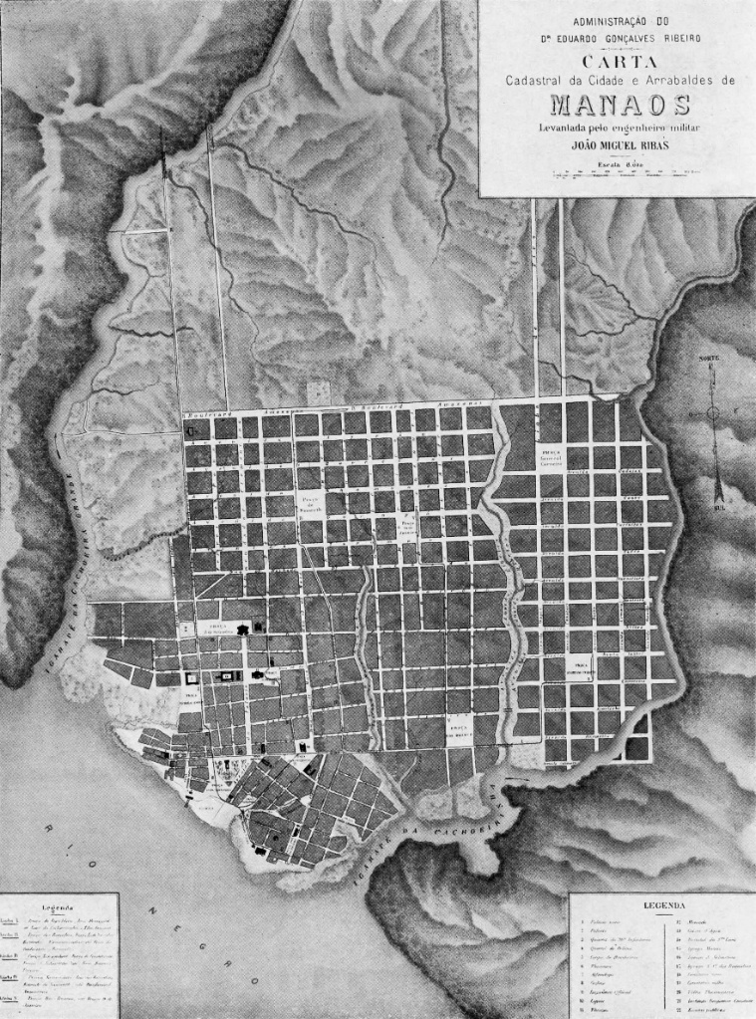
. Tramway lines, Manaus 1895 Eduardo Ribeiro Plan by João Miguel Ribas, 1895

Team and collaborators
Instructors: Gabriella Carolini (MIT – DUSP) and Angelo Bucci (MIT – Architecture, with a limited and mostly remote participation during the Fall)
Guest Lecturer: Marcelo Coelho (MIT – Architecture and Design Intelligence Lab); Gabriella Bilá
Brazilian University Partners: Marcos Cereto (UFAM - Architecture), and NAMA (Amazonia Lab); Alexandre Delijaicov (USP - Architecture and Urbanism, and GMF - Fluvial Metropolis Team Lab)
Exhibition Leads: Marcelo Coelho (MIT – Architecture and Design Intelligence Lab); Gabriela Bila Advincula (MIT – Media Lab)
Client: Washington Farjado (Inter-American Development Bank – Cities Lab)

Schedule July / draft version program / July 1st to 10th
day | date | activity
1 TUE | JUL 01 | Arrive from Boston
2 WED | JUL 02 | Breakfast at the hotel Pousada dos Frades  Walking tour downtown (Hotel > Manaus Harbour / Public Market)  Lunch at the market  Boat tour Igarapés and waterfront  PARQUE DOS TRIBOS  2 horas (by boat from Igarapés to Parque das Tribos, through Rio Negro, mouth of Cachoeira, Igarapé Tarumã Acu, igarapé Bolívia Parque das Tribos)  Meeting and presentation from IDB 18.30h – at the Casina
3 THU | JUL 03 | UFAM - Federal University of Amazonas  Panel discussion: Marcos Cereto (Indigenous urban housing, parque das tribos / Mendrisio)  and Alexandre Delijaicov (USP)  Presentation from USP students on maps, data, and previous work in Manaus  Presentation from UFAM students on studio work in Manaus  lunch at the University  Implurb (Prefeitura da Manaus), gestão das águas planejamento municipal / parque das Tribos / eco-barreiras (to be confirmed)
4 FRI | JUL 04 | Visit to MUSA, Museum of Amazonia  Lecture by Fillippo Stampanoni, archaeologist and MUSA museum director  Lecture by Almir Oliveira (or on July 8th).  Lunch at MUSA  Visit to SUFRAMA  Lecture by Adamilton Mourão: sobre a criação da Suframa, desenvolvimento industrial, crescimento urbano)  (to point out PROSAMIM sites)
5 SAT | JUL 05 | Visit to Carero das Varzea (palafitas) – by public boat
6 SUN | JUL 06 | Workshop day in hotel  TBD – meeting with architect of Casina  Teatro Amazonas – Amazonas Filarmônica, “From Vienna With Love To Manaus”, singer:Tamara Trojani; conductor: Konstantin Schenk, como regente
7 MON | JUL 07 | Visit to Severiano Porto Watertower – Constantino Nery
8 TUE | JUL 08 | Visit to Parque das Tribos, Vanda Witoto  (participação do Almir, TBD)  Visit to Archives and Collection (City Planning Department, Instituto Durango Duarte)  Closing Dinner (Restaurante Caxiri Manaus)
9 WED | JUL 09 | Visit with Semy Ferraz – Instituto Aegea – Aguas de Manaus – 9am  Visit to Estação de tratamento (Educandos) 11-12pm
10 THURS | JUL 10 | Departure from Manaus

Work plan and Schedule of Deliverables September – December / Fridays, from 9:30am to 12:30pm
phase | week | date | activity
phase 1:  CONCEPT  (group/shared research) | 1 | SEP 05 | Presentation  Angelo Bucci and Gabriella Carolini  introduction to phase 1: concept  introduction to exhibition partners: Marcelo Coelho, Gabriela Bila Advincula, Selby Nimrod
phase 1:  CONCEPT  (group/shared research) | 2 | SEP 12 | lecture by Marcos Cereto  IDB Joins via Zoom – Discussion of Theories of Change  Gabriela Bila Advincula, MIT Media Lab, lecture on Belem and the COP30 exhibition  Desk crits
phase 1:  CONCEPT  (group/shared research) | 3 | SEP 19 | Students Holiday
phase 2:  DEVELOPMENT 1 | 4 | SEP 26 | lecture by Alexandre Delijaicov (via zoom)  PINUP  Introduction to phase 2: development
phase 2:  DEVELOPMENT 1 | 5 | OCT 03 | Desk crits
phase 2:  DEVELOPMENT 1 | 6 | OCT 10 | Desk crits
phase 3:  COP 30 PREP | 7 | OCT 17 | PINUP / pre closing  Introduction to Phase 3: COP 30 Prep
phase 3:  COP 30 PREP | 8 | OCT 24 | Desk crits (Angelo in Cambridge)
 | 9 | OCT 31 | Final prep/review for COP 30 exhibit
 | 10 | Nov 7 | COP 30 Installation (optional brief trip to Belem)
phase 4: IDB Blog & CORREA SYMPOSIUM | 11 | Nov 14 | Updates & discussion of reception at COP 30  IDB Blog prep  MIT-LCAU symposium planning
 | 12 | Nov 21 | IDB Blog drafting  Prep for MIT-LCAU Charles Correa Symposium
 | 13 | Nov 28 | Thanksgiving Break
 | 14 | Dec 5 | Finalizing drafts for IDB Blog and presentations for MIT-LCAU Charles Correa Symposium: The Fluvial Amazonian City of the Future – Manaus 2025*
*MIT-LCAU Charles Correa Symposium will be a day-long event featuring this class’s work for the MIT community, and will be scheduled for the beginning of the Spring term.

Readings (* denotes priority)
*Fernanda Magalhaes and Eduardo Rojas (2007). Facing the Challenges of Informal Settlements in Urban Centers: The Re-urbanization of Manaus, Brazil. IDB Publication.
Stein, D. and Valters, C. 2012. Understanding ‘Theory of Change’ in International Development: A Review of Existing Knowledge. JSRP Paper 1. The Asia Foundation.
*Tavares, P. 2010. Modern Frontiers: Beyond Brasilia, the Amazon, Chapter 9 in Latin American Modern Architectures: Ambiguous Territories, edited by Patricio del Real and Helen Gyger. https://www.paulotavares.net/beyond-brasilia
*Campbell, J. M. (2015). "Indigenous Urbanization in Amazonia: Interpretive Challenges and Opportunities." The Journal of Latin American and Caribbean Anthropology 20 (1).
*Chernela, J.M. (2015), Directions of Existence: Indigenous Women Domestics in the Paris of the Tropics1. The Journal of Latin American and Caribbean Anthropology, 20: 201-229. https://doi-org.libproxy.mit.edu/10.1111/jlca.12135
do Couto, E.V., Carletti, R., de Vries, W.T. and Durán-Díaz, P., 2024. Spatial and temporal effects of urban growth in Manaus: examining urban and periurban sprawl in the heart of the world's largest tropical rainforest, Brazil. In Modern Cartography Series (Vol. 11, pp. 409-428). Academic Press.
*Pioletti, M., Cotella, G., Schor, T. (2023). Sustainable Spatial Development in the Urbanised Amazon: Promoting Circular Bioeconomy in the Manaus Metropolitan Region. In: Aguilar-Rivera, N., Borsari, B., R. B. de Brito, P., Andrade Guerra, B. (eds) SDGs in the Americas and Caribbean Region. Implementing the UN Sustainable Development Goals – Regional Perspectives. Springer, Cham. https://doi-org.libproxy.mit.edu/10.1007/978-3-031-16017-2_96
*Xhulio Binjaku, Angelo Bucci, Marcos Cereto 2024. Modern Imagination and Modern Architecture in Amazonia, gta Verlag.
Mostafavi, Mohsen and Doherty, Gareth (2016). Ecological Urbanism in Latin America and Caribbean, in Urbe, Rev. Bras. Gest. Urbana 8 (1), Apr 2016.
*Pontes, Louise Barbalho Cardoso, Ana Cláudia Duarte (2016) Open spaces: windows for ecological urbanism in the Eastern Amazon, in Urbe, Rev. Bras. Gest. Urbana 8 (1), Apr 2016.

Kanai, J. M. (2014). On the Peripheries of Planetary Urbanization: Globalizing Manaus and its Expanding Impact. Environment and Planning D: Society and Space, 32(6), 1071-1087. https://doi.org/10.1068/d13128p

Fajersztajn, Laís Alves, Nilmara de Oliveira Coelho, et al. (2016)How can ecological urbanism promote human health? Ecological Urbanism in Latin America and Caribbean, in Urbe, Rev. Bras. Gest. Urbana 8 (1), Apr 2016.

Gandy, M. (2015), From urban ecology to ecological urbanism. Area, 47: 150-154. https://doi-org.libproxy.mit.edu/10.1111/area.12162

Silva, R.H.; Zwarteveen, M.; Stead, D.; Bacchin, T.K. Bringing Ecological Urbanism and Urban Political Ecology to Transformative Visions of Water Sensitivity in Cities. Cities 2024, 145, 104685.
Khalaji, F., Zhang, J., & Sharma, A. K. (2025). Social and Economic Impacts of Water Sensitive Urban Design: A Review. Water, 17(1), 16. https://doi.org/10.3390/w17010016

