4.184 Architecture of Autarky
Understanding the Material World via Simulation of Earth-Surface Exploitation and Constraint

Design Workshop/Seminar 3-0-9 Mon 1-4pm Room 4-144
Prof Mark Goulthorpe TA TBD

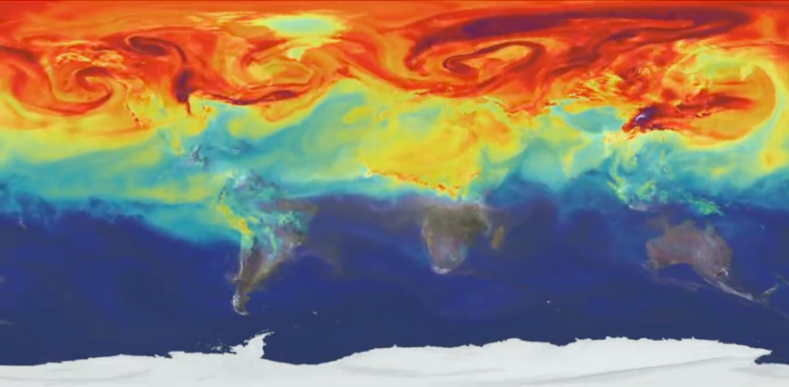

NASA video simulation of Global CO₂ accumulation Simulation of global shipping lines (SE Asia)

Exquisite Simulation
Complex atmospheric and oceanic systems, changing through time, have been rendered brilliantly legible through sophisticated simulations by groups such as NASA absorbing decades of satellite data into distilled visual narratives:

- depictions of sea-level change allowing for melting ice, changing oceanic currents, and the spin of the earth, show surging swell on the east coast of Asia and the US, peaking at the faster-spinning equator

- the seasonal production and absorption of CO₂ by diminishing biomass, augmented by dispersed plumes from increasing urban energy-use, are made legible as a decades-long planetary “breathing”

- filigree shipping lines, color-coded per commodity, offer eerily beautiful videos depicting vectorial lines of desiring-production that coalesce and disperse as networks of supply and demand

Such elegant depictions offer startling and simple clarity to otherwise intractable systems. By offering visual legibility, such issues are absorbed into everyday thinking, despite their complexity.

By contrast, there are few sophisticated depictions of earth-surface exploitation and the ant-like spoil-heaping at civilizational scale of materials and energy – their re-distribution and transformation into flows of late-industrial “stuff”. Undergirding commodity markets is a seemingly limitless energy supply and a post-WW2 global free-trade economic order, both largely invisible given their ubiquity.

Material Realism
We will learn principally from two masterful accounts of our energy and material civilization, both engaging and accessible: The Many Lives of Carbon by Dag Olaf Hessen (charting the cycles of all organically-derived materiality), and The Material World by Ed Conway (focusing on 6 base mineral/ metal commodities that essentially underpin the contemporary material world – sand, salt, iron, copper, oil and lithium). Doubtless others will come into view, such as rare earth metals, or cobalt…
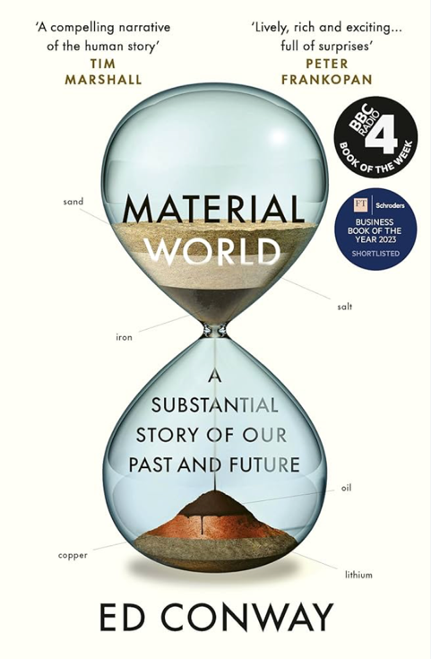
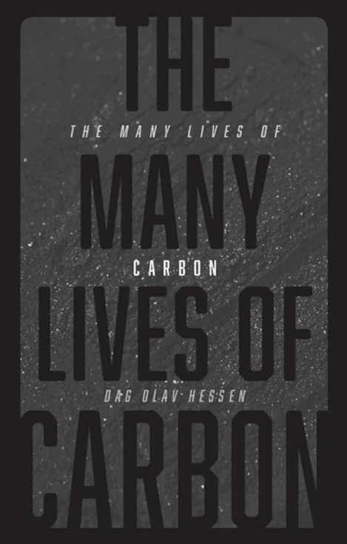

Students will divide chapters and summarize to the class with exquisite diagramming to clarify complex issues

Part 1 of the workshop (working individually or in pairs) will seek to de-mystify key aspects of contemporary materialism to graphically portray the fragility or threat implicit in its geo-political and environmental portent, evidently with focus on architectural materials/methods, against a backdrop of mounting environmental stringency and a doubling of buildings by mid-century. In other words, we’ll deploy architectural aptitude to offer striking new ways to capture the complex reality of our material world, which will likely benefit from being witnessed through time (for instance in the startling new efficiencies of copper production that seems to have even outpaced Moore’s Law).
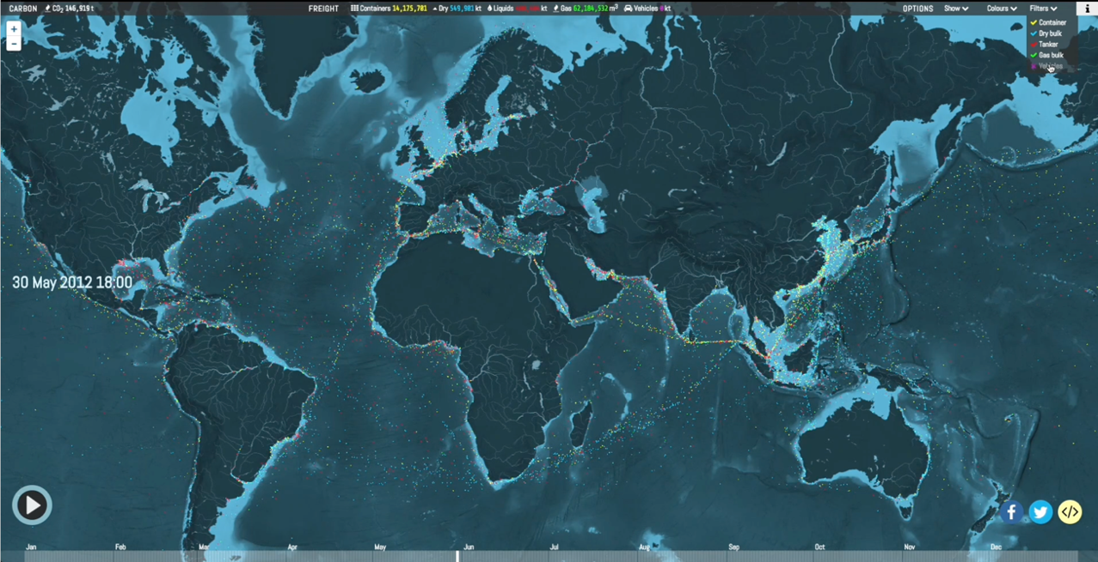

Global Shipping lines channeled through pinch-points such as Suez or Panama canals
Part 2
“Autarky is an economic system of self-sufficiency and limited trade. A country is said to be in a complete state of autarchy if it has a closed economy, which means that it does not engage in international trade with any other country.” Concise Oxford Dictionary of Politics and International Relations

Part 2 of the workshop will focus on the consequences when the assumptions of limitless material and energy availability are disrupted, as during Covid (supply-chain and labor disruption), or the Ukrainian war (imminent European recession through restriction of Russian natural gas), or the current imposition of US tariffs and the vision of autarky that they imply – a rebuke to the pervasive global free-trade hegemony. Akin to putting sticky tape on a balloon and then inflating it, so restrictions of material and energy supply necessarily distort architectural form (no-labor reconstruction in Ukraine, for instance). Copper might be mined and crushed in Chile, the dust shipped to China for refining, shipped back to the US to be drawn into wires, before being trucked to an east coast building site subject to US electrical codes; what happens when any of the regimes become autarkic?
Each student will be asked to develop or analyze an architectural element or assembly that allows for varying degrees of autarky in being able to adjust the material and/or energy assumptions of the project as parametric variants: what design and technical aptitude would this require?
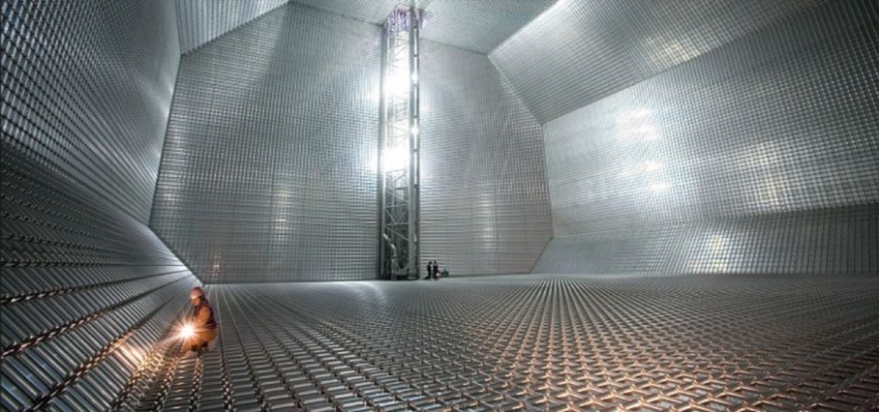
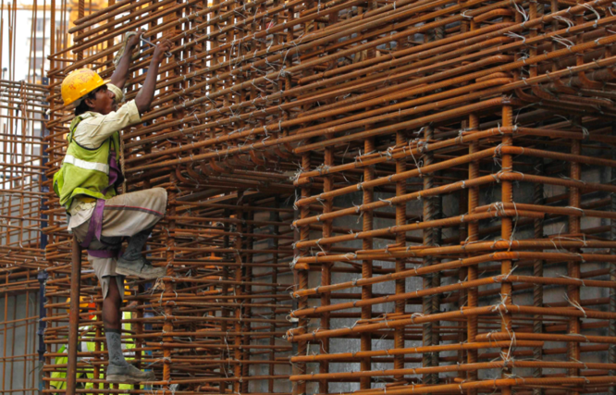

Interior of an oil tanker during construction Steel re-bar in reinforced concrete footings

Pedagogy
The pedagogical ambition is to engender deep insight into the base conditions that really establish any given material paradigm through history, rendered in a manner that offers graphic elegance to its complexity of extraction + production (part 1). But to also now develop a plasticity of mind that allows for transforming a design proposal in response to variance of material conditions, be they legal, economic, environmental, ethical (part 2). It seems likely in coming decades that labor, goods and energy will be subject to supply constraint, materials such as rare-earth magnets, or lithium for electric batteries, already targets of global economic policy: the Congo re-living the trauma of colonial exploitation to extract rubber in C19th, now lithium and cobalt in C21st.
Ability to assimilate any material constraint into architectural form, pre-facto rather than post-facto, looks to tease out a new spatial-material aptitude to be elegantly instantiated as/in design thinking.
Calendar (Room 4.144 1pm-3pm)

Sept 8 Course introduction and assignments – MG
Sept 15 Student-led discussion of The Material World and The Many Lives of Carbon by topic
to bring the whole class up to speed on organic and inorganic production and supply

Sept 22 The Material World student presentations (sand, salt, iron, copper, oil, lithium)
(render with graphic elegance the complexity/salience of each material through time)
Sept 29 The Many Lives of Carbon student presentations (diagrammatic summation)
(render with graphic elegance the complexity/salience of the carbon cycle)
Sept 29 Collective workshop to initiate Material Simulation initiative
(everyone to bring examples, visions, hallucinations… to brainstorm collectively)
Oct 6 Initial review of simulation projects – a first attempt at graphic capture
Oct 13 Indigenous Peoples' Day (no class)
Oct 20 Part 1 Review
(students present to an invited jury – may include Ed Conway and Dag Olav Hessen)
Oct 27 Introduction to Part 2 - MG Architecture of Autarky: from formal to material imagination (per Gaston Bachelard)
Nov 3 Student introductions to their proposed projects (can work in pairs)
Nov 10 Veterans’ Day (no class)
Nov 17 CarbonHouse: overview of all-wood and all-carbon architectures (DECOi)
Nov 24 TBD
Nov 31 TBD
Dec 7 Last Class: discussion of emerging material imagination engendered by collective insights
Dec 15 Part 2 Final review (with guest reviewers)


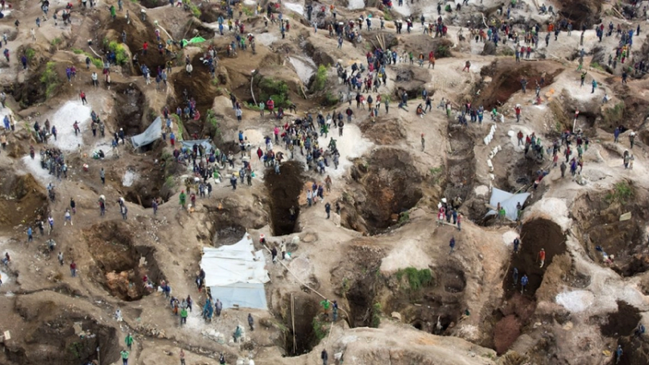

Lithium / Cobalt Extraction


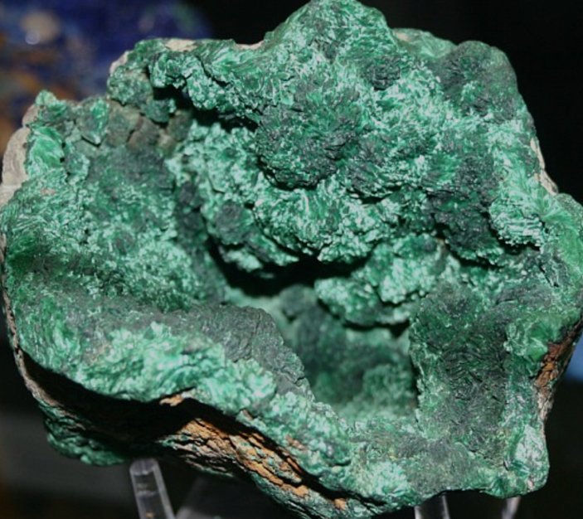
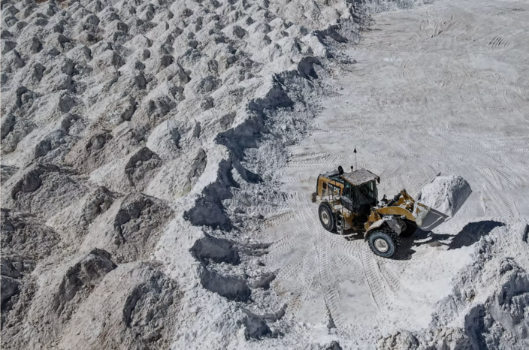
Copper Mining


Oil Drilling / Fracking


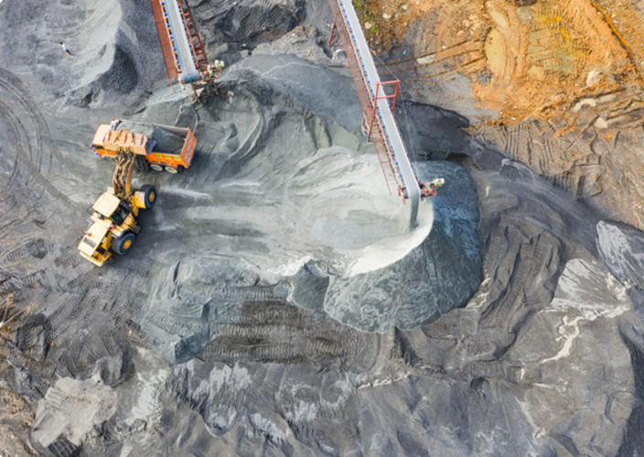
Sand extraction
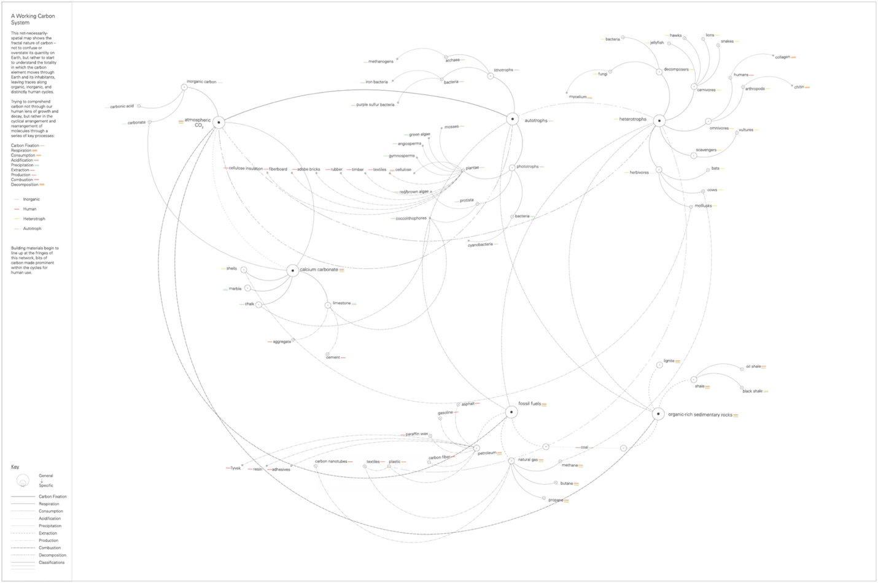
The Carbon Cycle

Prior Carbon Cycle Diagramming

